Dance Competition
Packing Checklist

COSTUMES
- Costumes
- Undergarments that DON’T show through costume
- Tights (+ extra pair)
- Textile accessories (i.e. gloves, belts, etc.)
- Dance shoes for each costume
- Rhinestone Choker (CSDC)
- Rhinestone Earrings (CSDC)
- Rhinestone Ponytail Holder (CSDC)
- Rhinestone Bobby Pins (CSDC)
- Costume specific accessories for each costume
- Oversized Button-down Shirt/Cover-up
- Safety Pins
- Tide-To-Go
- Double-sided tape
- Sewing kit with hooks and eyes and other fasteners for possible repairs
- Lint brush
- Static Guard
- Props
- Fabri-Tac and/or E6000 Glue
MAKEUP
- Foundation
- Powder
- Concealer
- Makeup Brushes/Applicators
- Q-tips & Cotton Balls
- Blush
- Makeup Primer (helps makeup go on more smoothly)
- Eyeshadow (3 shades: cream, med. brown, dk. Brown)
- Eyeliner (black)
- WP Mascara (black)
- False Eyelashes (#53 at least 2 pair)
- Eyelash glue [tube (comes in clear or black) for the eyelashes and clear brush-on for rhinestones]
- Lip Balm
- Lipstick (lip liner if desired)
- Lip Gloss
- Rhinestones (5mm - clear)
- Spray Glitter for body/hair/shoes (Silver)
- Eye Makeup Remover and Makeup Removal Wipes
- Clear Nail Polish
- Mirror

HAIR
- Ponytail holders (match hair color)
- Small Clear Hair Elastics
- Hair Bun Donut
- Hair Pins (match hair color – Sally’s Beauty Supply)
- Bobby Pins (match hair color)
- Hair Bun Nets (match hair color – Sally’s)
- Hair Brush/Comb
- Travel Flat Iron
- Flat Iron Spray
- Max Hold Hairspray with humidity control
- Hair Gel/Pomade
- Small spray bottle for water

FIRST AID
- Clear Band-Aids
- Blister Pads/Moleskin
- Hot/Cold Packs
- Ace Bandage/Wraps
- Neosporin
- Children’s and Adult Pain Reliever, Pepto Bismol, Antacid
- Prescription Meds

OTHER H&B NEEDS
- Deodorant
- Feminine Hygiene Supplies
- Dry Body Spray (Arm and Hammer)
- Tweezers
- Nail Clippers
- Nail Polish Remover Wipes
- Moisturizer
- Kleenex
- Colgate Wisps (there is a Dollar Tree version)
- Razor/Shaving Cream
- Glasses + sport band/Contacts/Cases

FOOD & DRINK
- Water Bottle
- Healthy Snacks (granola bars, cheese sticks, fresh fruit, carrots & celery, peanut butter, crackers, Luna bars, etc.)
- Wet Ones/Paper Towels
- Grocery Bags
- Small Insulated lunch bag
- Cooler with easy portable lunch/breakfast items (save $$ and eat healthy)

OTHER USEFUL ITEMS
- Dance Music
- Portable Bluetooth Speaker
- Collapsible Laundry Basket/Laundry Bag
- Ziploc Bags
- Clothespins or Binder Clips
- Sketchpad/Notebook
- Pens, pencils, highlighter
- Coloring Books/Crayons/Books/something to help pass the time
- Earbuds
- Phone (make sure you have room for photos backstage)
- Charger
- Change of clothes/underwear (this is where all of those Center Stage t-shirts come in handy and it makes packing for the family easy if you have enough for everyone. CSDC t-shirts and jeans/leggings for the family!)
- Lightweight Jacket/Warm-up Pants
- Slip-on shoes & Extra Socks/Flip-Flops
- Small Blanket
- Massage Roller/Stretch Bands

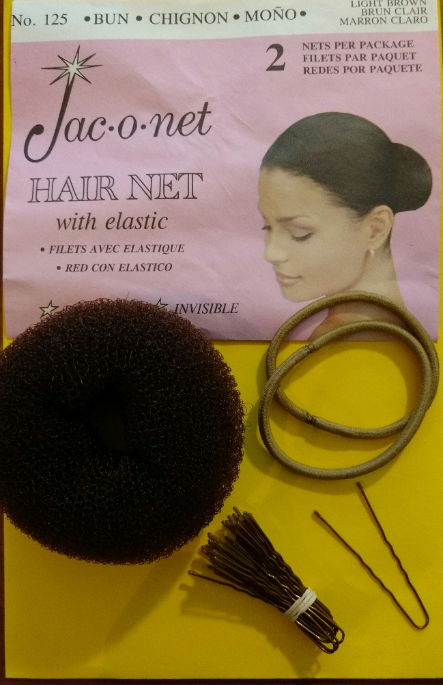
Favorite Bun Accessories, especially the net

